

Practical Report

**For IoT Practical**

2022

Darshan Ramjiyani (DSP)

DOCS, KSKV Kachchh University



* **5.E1 – Simple Analog and Digital Input**

Create an ATM password verification clone using arduino and **4x4 Keypad**.

**Arduino Code:**

const int baudRate = 9600;

const int passwordLength = 10;

const int keypadRows = 4;

const int keypadColumns = 4;

const char keypadKeys[keypadRows][keypadColumns] = {

{'1', '2', '3', 'A'},

{'4', '5', '6', 'B'},

{'7', '8', '9', 'C'},

{'*', '0', '#', 'D'}

};

const int rowPins[keypadRows] = {12, 11, 10, 9};

const int colPins[keypadColumns] = {8, 7, 6, 5};

char passwordChars[passwordLength];

void setup() {

Serial.begin(9600);

for (int row = 0; row < keypadRows; row++)

{

pinMode(rowPins[row],INPUT);

digitalWrite(rowPins[row],HIGH);

}

for (int column = 0; column < keypadColumns; column++)

{

pinMode(colPins[column],OUTPUT);

digitalWrite(colPins[column],HIGH);

}

pinMode(LED_BUILTIN, OUTPUT);

digitalWrite(LED_BUILTIN, HIGH);

setPassword();

}

void loop()

{

Serial.print("[Arduino] : Enter password to continue :- ");

int charEntered = 0;

char passwordEntered[passwordLength];

while(charEntered < passwordLength)

{

char keyPressed = getPressedKey();

if(keyPressed != '\0')

{

passwordEntered[charEntered] = keyPressed;

Serial.print("*");

charEntered += 1;

}

}

Serial.println();

if(passwordLength == charEntered)

{

if(matchPassword(passwordEntered))

{

Serial.println("[Arduino] : Password Matched. Welcome to the ATM.");

}

else

{

Serial.println("[Arduino] : Password doesn't match.");

}

}

else

{

Serial.println("[Arduino] : Password matching failed. Try to restart the program.");

}

delay(10000);

}

void setPassword()

{

Serial.println("[Arduino] : Please create password first.");

Serial.print("[Arduino] : Enter your ");

Serial.print(passwordLength);

Serial.print(" digit password :- ");

int numCharPasswordEntered = 0;

while(numCharPasswordEntered < passwordLength)

{

char keyPressed = getPressedKey();

if(keyPressed != '\0')

{

passwordChars[numCharPasswordEntered] = keyPressed;

Serial.print("*");

numCharPasswordEntered += 1;

}

}

Serial.println();

if(passwordLength == numCharPasswordEntered)

{

Serial.println("[Arduino] : Password has been created successfully.");

}

else

{

Serial.println("[Arduino] : Password creation has been failed! Restart program to solve the issue.");

}

}

char getPressedKey()

{

char key = '\0';

for(int i = 0; i < keypadColumns; i++)

{

digitalWrite(colPins[i],LOW);

for(int j = 0; j < keypadRows; j++)

{

if(digitalRead(rowPins[j]) == LOW)

{

delay(20);

while(digitalRead(rowPins[j]) == LOW);

key = keypadKeys[i][j];

}

}

digitalWrite(colPins[i],HIGH);

}

return key;

}

bool matchPassword(char enteredPassword[passwordLength])

{

bool isMatch = true;

for(int i=0; i < passwordLength; i++)

{

if(enteredPassword[i] != passwordChars[i])

{

isMatch = false;

}

}

return isMatch;

}

**Output / Circuit Diagram:**

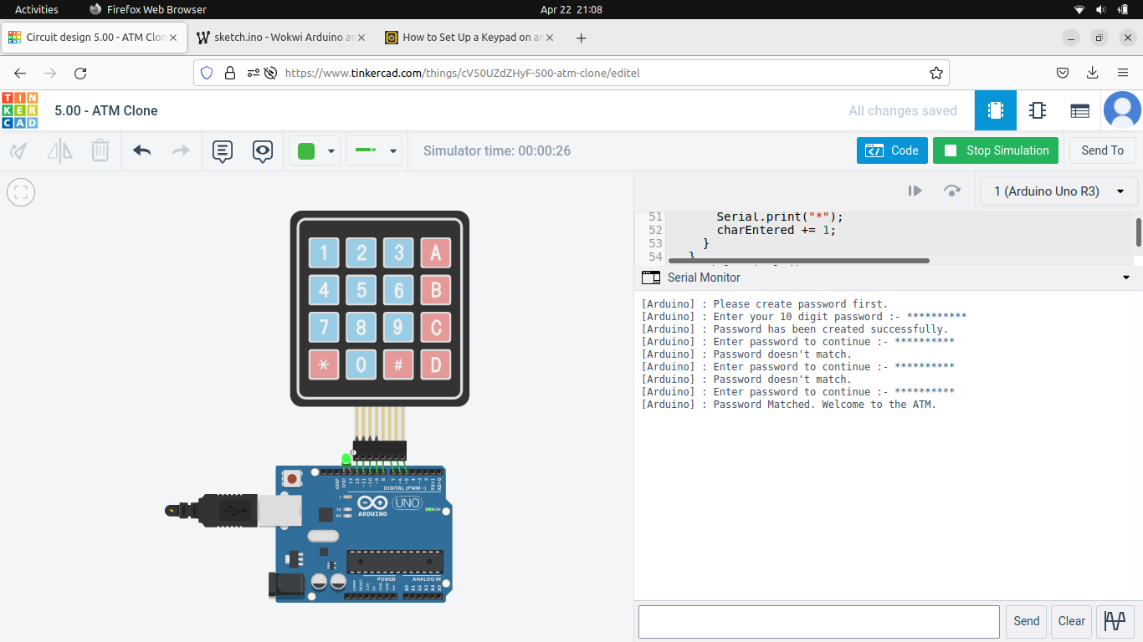

**Darshan Ramjiyani**